

**TITLE:** Corporate Marketing Officer

**DEPARTMENT:** Marketing

**RESPONSIBLE TO:** Head of Marketing + Conference & Events Sales Manager

**HOURS:** 24 hours per week

**PAY**: £26,000 Per Annum, Pro-Rata

**Contract**: Permanent

**Purpose of Job**

This is an exciting role within the organisation that focusses on B2B and B2C marketing activities that raise the profile of The Guildhall Trust and the Conferencing & Occasions offering across our venues.   
  
You will deliver multi-channel campaigns that raise awareness of The Guildhall Trust and its charitable activities, promote the Trust as a cultural consultancy to potential clients and support the Conferencing & Sales team to achieve budget targets.   
  
Making connections, developing networks, exploring opportunities - you will attract new business.   
 **Organisation Chart  
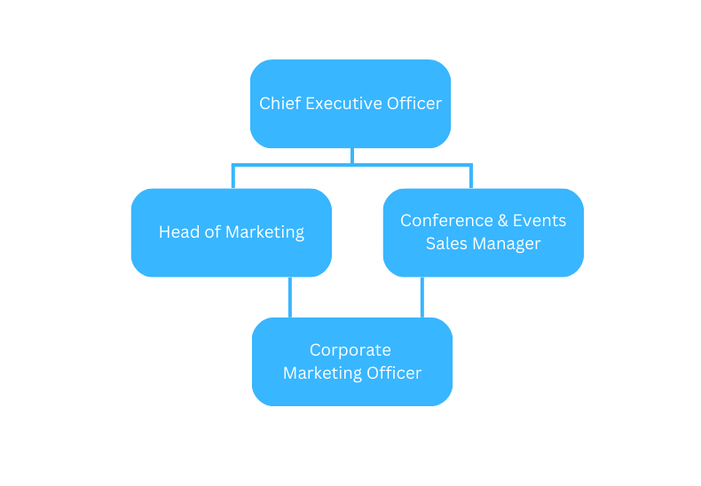  
  
Principal Responsibilities**

1. To support the institutional and strategic marketing initiatives as established by the Strategic Marketing Committee. You will work with the CEO and Head of Marketing to develop a multi-channel action plan to promote The Guildhall Trust that targets key client groups, undertaking research and analysis as required to inform and adapt the plan.
2. To deliver a multi-channel action plan to promote the brand and activities of The Guildhall Trust across digital, print, PR and networking.
3. To promote the Conference & Meetings offer of Portsmouth Guildhall to corporates locally, regionally and nationally. You will deliver paid and organic digital campaigns, an e-marketing strategy, enhance our online listings and develop new connections at networking events.
4. To build The Guildhall Trust’s LinkedIn profile and activity to help meet business objectives.
5. To support the Fundraising Manager in delivering sponsorship and fundraising initiatives which achieve targets.
6. Optimise campaign plans and targeting strategies and utilise analysis techniques to exceed targets and deliver growth to the business.

**Location**

Your main place of work will be the offices of The Guildhall Trust at Portsmouth Guildhall. Occasional travel will be required to our other venues, White Rock Hastings, and any future organisations that become part of the Trust.

**Other**

The nature of the work undertaken by the post holder will be required to work daytime weekdays. Occasional evening and weekend working may be required.

**Budget**

Delivery of marketing plan within agreed budget overseen by the Head of Marketing.

**Physical**

None

**Context**

The Guildhall Trust was formed in 2011 to take on the management of Portsmouth Guildhall, one of the South of England’s largest and busiest concert halls. The Trust became a charity in 2013 with a board of trustees, a trading company and a clear vision for its future.

The Trust has successfully developed the Guildhall into a vibrant concert hall, with a first-class programme of concerts as well as a Get Involved programme of community engagement. The Trust has diversified the business of the Guildhall with income streams from conferencing and new events. The Trust is working on a long-term capital project, Guildhall Renaissance, to develop a first-class venue for the future.

Over 275,000 people a year engage with Portsmouth Guildhall and the Trust’s various activities. We host approximately 130 large concerts per annum, 70 smaller gigs in our Studio, over 6,500 school children participate in Dance Live, one of our leading events, and 80,000 people annually attend conferences and events.

From 1st February 2024, The Guildhall Trust added The White Rock Theatre, Hastings, to its portfolio of venues and has aspirations to expand further in the coming years. Applying a similar model to the White Rock, the Trust seeks to revitalise the concert programme, create a secondary Studio performance space, deliver a charitable programme of activity and develop the opportunity for Conferencing and Occasions business in the venue.

The core purpose of The Guildhall Trust is to deliver inspirational opportunities so that people want to engage with culture and the creative economy. The Guildhall Trust’s vision is that it will become a leading cultural organisation which places our communities at the centre of everything we do so that we can inspire, entertain and transform lives. This is achieved through our commercial success.   
  
This role sits within the Conferencing & Sales and Marketing teams but will also work closely with the CEO, COO, Venue Director, Head of Learning & Participation and Fundraising Manager. As we seek to expand our business, you will raise the profile of the organisation to all stakeholders including businesses, organisations, local authorities, sector related clients and partners.

**Person Specification**

This acts as selection criteria and gives an outline of the type of person the characteristic required to do the job.

Essential: - without which the candidate would be rejected

Desirable: - useful for choosing between two good candidates

|  |  |  |
| --- | --- | --- |
| Attribute | Essential | Desirable |
| Experience | Experience of working within a marketing or sales team for at least 2 years  Experience of delivering effective multi-channel marketing campaigns   Experience of developing content for multiple audiences  Knowledge of the Conferencing market | Working within the Conferencing/Events industry  Experience of working on fundraising campaigns  Networking  Experience of CRM and GDPR legislation |
| Skill/ Abilities | Excellent interpersonal and communication skills  Excellent copy writing skills with a critical eye for detail  A skilled social media user and analyst across several platforms including Facebook, Instagram, LinkedIn and Twitter  Highly competent IT skills  Hands on approach and team player  A strong marketeer | Use of Adobe Creative Cloud – including In Design, Illustrator, Photoshop, Lightroom, Premier Pro, After Effects   Use of Wordpress   Photography/Videography/Animation |
| Education and training | Relevant Further Education qualification or equivalent |  |
| Other | Willing to work evenings and weekends as required | Driving License and use of car |